

**Water Butt Faculty Application**

**Ecosure 750 litre Water Butt V1 details – Black**

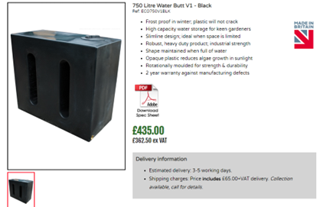

* **PCC chosen Option** – positioned against south wall of Chancel utilising existing cast-iron downpipe.

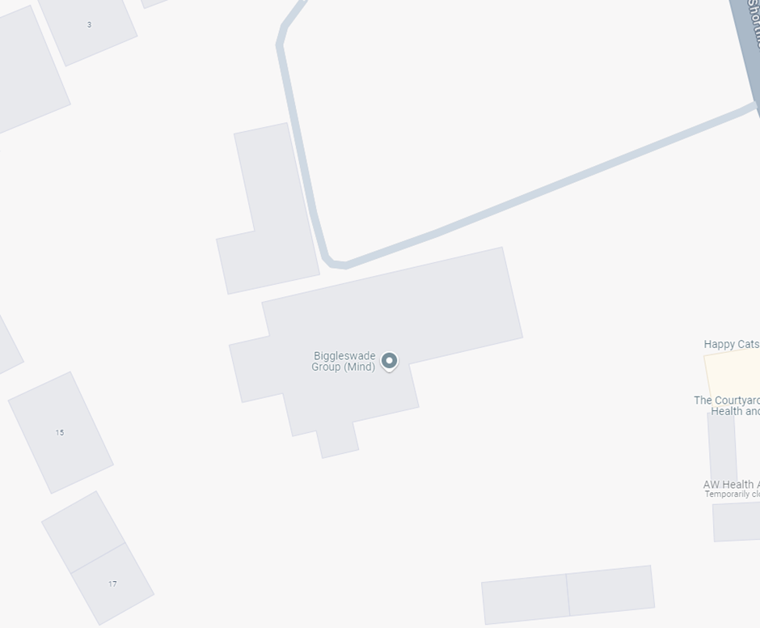

LOCATION

Positioned against south wall of Chancel utilising existing cast-iron downpipe and would be behind the tomb in the image below left and nestling in front of the downpipe/drain and to the left of buttress just below projecting sailing course.

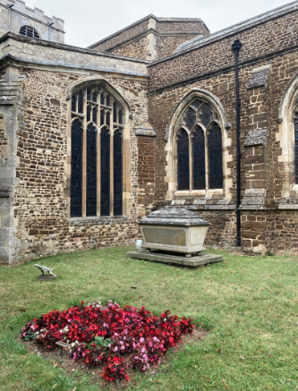 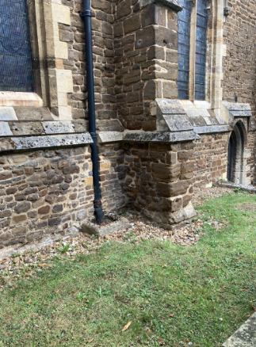

The drawing below (which I sent to CP on 31 January 2024) indicates approximately how this water butt would sit alongside the buttress.

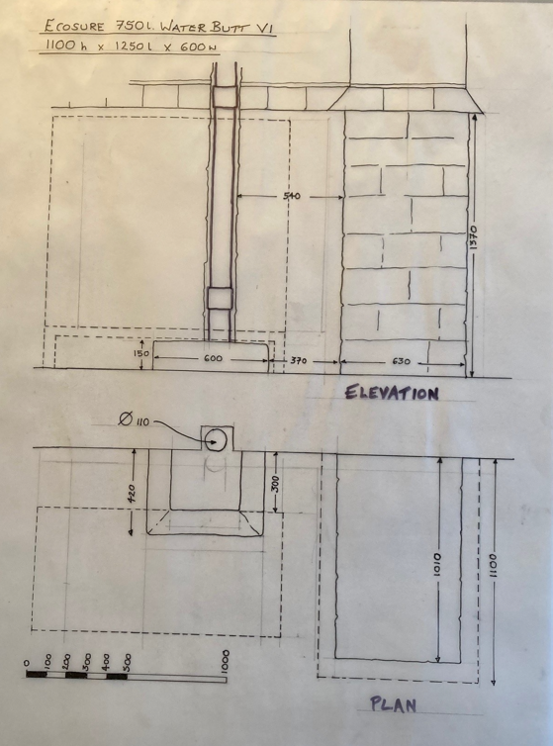

**Mark Simmons**

**8 September 2024**